King Kinsella | Irishtown Sports  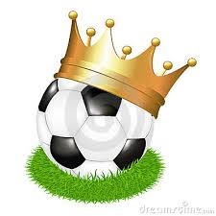
 | PAGE 2 King will not bow down PAGE 3 King and Legends |  |  |  |  |  |  | BACK PAGE Kinsella’s Charity Walk with RICC  May 5, 2014 & Donators
King of Cambridge 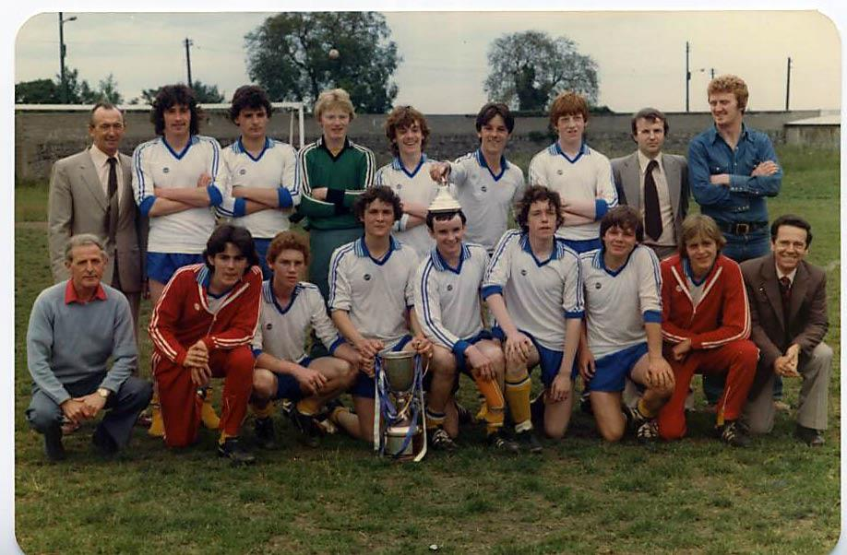 |  |  |  |  |  |  |  |  |  | King’s Cause  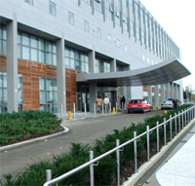  St. Vincent’s Hospital  Kinsella has not taken his foot off the gas since the first day he started his campaign for St. Vincent’s Foundation/Neurology.  The Dubliner’s story was published in the Irish World Newspaper, USA. “We are making a song and video to further promote our cause and so far we have raised over 1,000 EURO,” said the proud King.  “Thanks everybody for your generosity.”
THE DAY KINSELLA WAS CROWNED KING
Top Left: Mr. Dent, (Terry’s Dad) Paul Byrne, Gerry Whelan, Jody Byrne, Rocky O’Brien, Michael Waters, Paul Ennis, Mr. Pepsi, Tommy Gaynor
Bottom Left: Leo McDonagh, Michael Behan, John Montgommery, Michael Dunne, Alan ‘King’ Kinsella, Scotchie Byrne, Terry Dent, Tony Caldwell, Mr. Byrne, (Scotchie’s Dad)

FAI applicant Alan Kinsella is now claiming he is the King of Cambridge
Alan Kinsella the Dubliner who had the audacity to apply to the FAI for the Republic of Ireland’s head coach position is at it again. This time the Irishtown bravado has claimed that he is King of Cambridge.  Locals are not having it. His mates are questioning his self- |  |  | 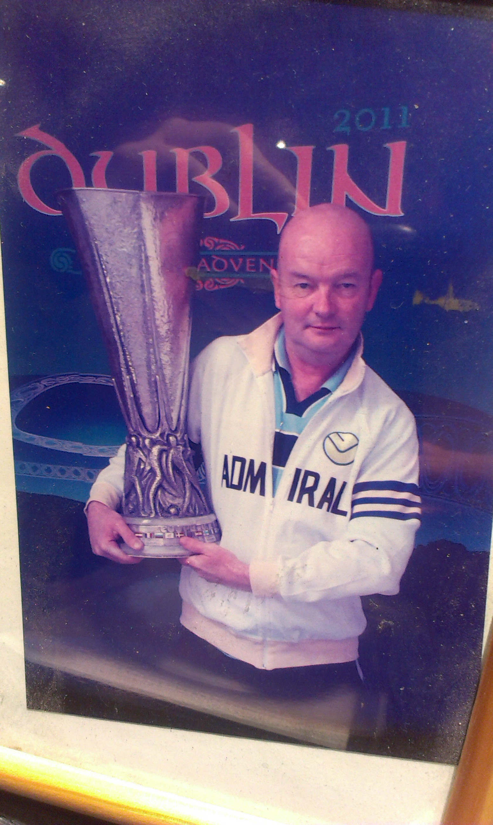  Kinsella Accepts KOC Trophy
 |  | proclamation.  “He’s not the King of  Cambridge, no way,”  a mate said. Kinsella  shrugged his shoulders,  looked at the doubters,  then turned to face the  music. “It doesn’t matter  if you look at all the  players who played for  Cambridge. I am still the  King of ‘em all, and  always will be,” Kinsella |  |  |  | said. “What do you mean you’re the King,” a mate asked. “You tell me,” replied Kinsella. “Does it mean you are the King of the pitch,” the man dared to ask the King.  “Listen, I was crowned  the King by my fellow players. You can  decide for yourself |  |  |  | what it means. Furthermore, I accepted the KOC Trophy back in 2011.  Make no mistake about it. I am the King of Cambridge,” Kinsella announced. The silence was deafening till everybody clapped but one or two  remained in doubt.
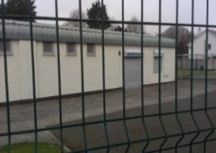  CFC Club House | Irishtown Sports
King of Cambridge continued…  And that is understandable.  In the late 1970s Kinsella played for Leo McDonagh’s Cambridge Boys FC. There was some serious company in this team. “And I never missed a game,” Kinsella interrupted. Michael Dunne and Terry Dent were excellent ball winners while Scotchie Byrne brought elegance to the back line. That’s Mick Waters crowing the King. Mick a very quick forward did a spell with Bohemians.  Beside Mick is Rocky O’Brien who played 190 games for Bohs as a pro. He finished his career with Sligo Rovers. Rocky scored twice against Rangers with Bohs wining 3-2 in the UEFA Cup. He scored 33 goals in total for the Gypsies. No doubt O’Brien was one of the main players in King’s Cambridge team, arguably their main player.  Last and by no means least Jody Byrne who could easily give Kinsella a run for his crown. Byrne played in the League of Ireland from1980s to the1990s. In his debut for Dundalk he kept a clean sheet. It was a sign of things to come. Once he joined Shamrock Rovers there was no looking back at the limited time he received for Dundalk. Jody played 196 league games for Rovers with an amazing 76 clean sheets. He played 302 competitive games 8 of them in the European Champion’s Clubs’ Cup. In 1990 he moved to Shels and helped the Reds to their first league title in 20 years. He finished out his career with Cork City then back to Dundalk. Jody played for the LOI under 21s against Italy. In Byrne’s first stint at Dundalk under Jim McLaughlin, a one Mister Alan ‘King’ Kinsella was also on Dundalk’s books, just for the record that is.  King will not Bow Down  Kinsella might get away with claiming that he is King of Leo McDonagh’s Cambridge but King over Joe Corcoran’s boys? In the early 1970s living legend Joe Corcoran managed and coached a Cambridge school  boys team that bewildered opponents.  In ‘76 their shock triumph over Home Farm in the FAI  Youth Cup put the Ringsend club into the history books of school boy football. This Cambridge team won their DDSL League every year during their time together. They won the 12C, 13A, 14A, 15A, 16A, 17A & U18 Premier Youths. They also won numerous Cups including U15 all Ireland. Proving that the win over Home Farm in ’76 was no fluke the boys went on to beat Waterford’s Tranmore Athletic 4-0 to keep the FAI Title for another year. |  |  |  |  | The Cambridge line up that day was Gerrard O’Neill, Gary Brown, Shane Chaney, Pat Nolan, Liam ‘Jack’ Dunne, Eugene ‘Gino’ Lawless, Alan Lewis, Brendan McEntee, Eamonn ‘Yaman’ Fitzgibbon and Paddy Joyce. Tom Ryan came in for Chaney and Jamesey Morris came in for Lewis. Stephen Walsh, Barry Casey and Simon ‘Mousey’ Gavin completed this Cambridge squad. Arguably one the best schoolboy teams Ringsend Park has ever produced.  Identifying the talent in this team was well underway by the time Paddy Joyce, Jackie Bailey and Jack Dunne represented the Leinster Youth Team in Dusseldorf, Germany 1977. It was the first Irish team to win away from home, beating German and English teams with style.  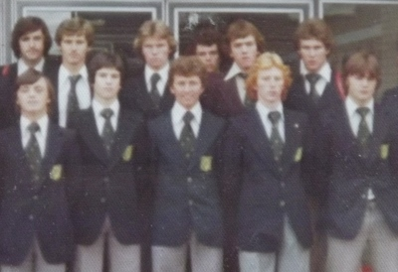  Bottom left: Jack Dunne. Bottom Right: Paddy Joyce  Beside Paddy the incomparable Jackie Bailey  Liam ‘Jack’ Dunne was with Shelbourne for a short time. Capped twice for his country at youth level Jack was an excellent passer of the ball. Pat Nolan played with Bohs for a short time, he could play games and not put a foot wrong for 90 minutes. Gino Lawless played for Bohs, Dundalk and Athlone Town. A powerful player who also played for the Irish U21 team. Paddy Joyce was with Manchester United for a short spell. He played for Bohs and Shels then went on to Waterford United. He also played for his country at youth level. Joyce could weave his way through games when defenders least expected it. Last and by no means least Jackie Bailey who was with Coventry City, tried out for Manchester City and Arsenal then finished with Shelbourne. Bailey was a graceful player on the ball with excellent vision.  We caught up with King and Bailey.
Fulham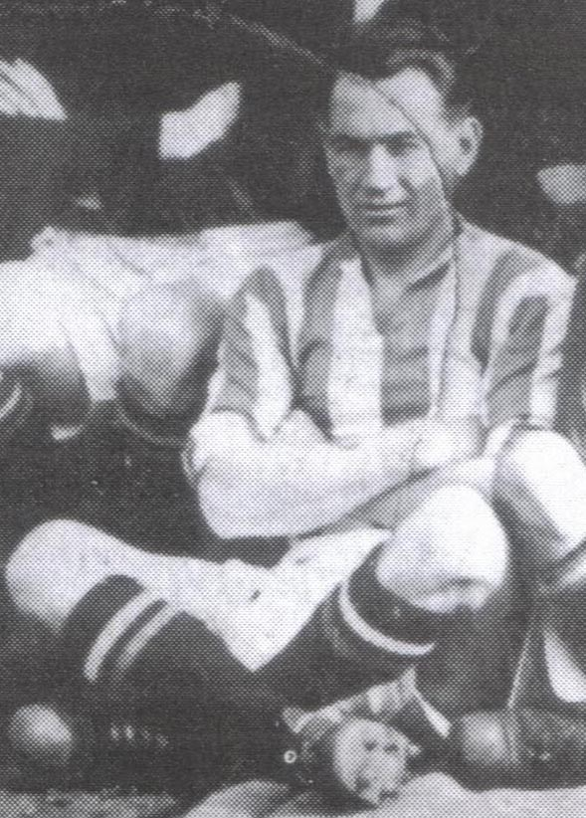am  King Reunites with Bailey after 20 Years  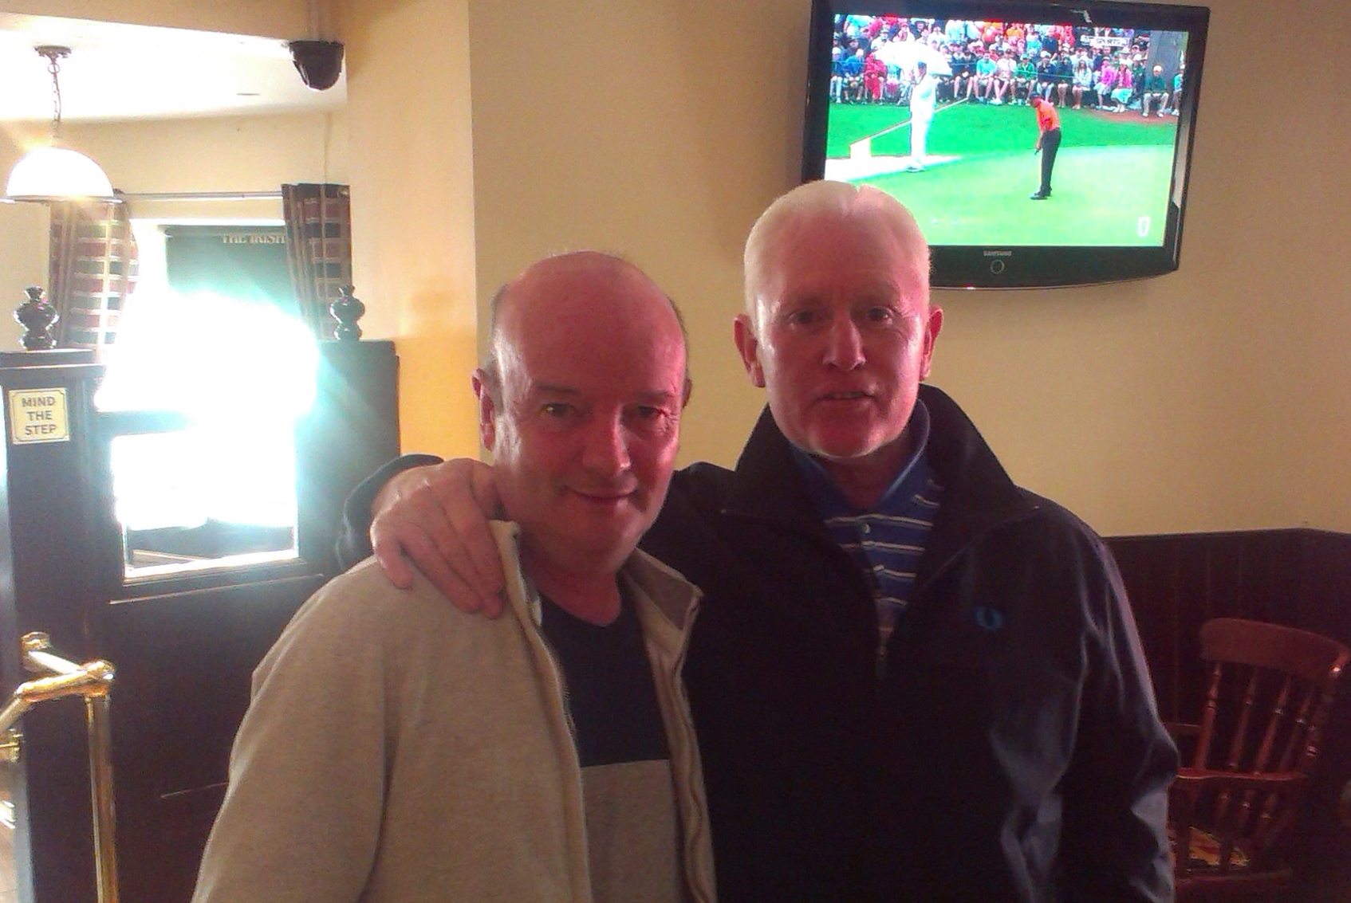  We asked the King of Cambridge what his title allured to. Was it simply a nick name? Was he saying he was the King of football? “I don’t like to repeat myself,” King remarked. “But I never missed a game as stated. I was a starter and I scored a lot of goals. I was never out of my league, never. Perhaps we can ask Mr. Bailey himself why I was crowned King of Cambridge. And in typical fashion Jackie replied. “There’s only one King … after me.”  Ringsend’s Rich History in the Game  The 1970s Cambridge Boys FC is just one football story to come out of Ringsend Park. For over 100 years Ringsend and its neighboring towns have been producing footballers of the highest order. Soccer is a tradition in places like Ringsend. It goes back to the late 1800s.  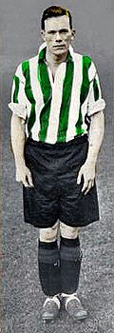  Ringsend is also known for its successful junior teams in both soccer and Gaelic football. But Valentine 'Val' Harris, Bob 'Give it to Bob' Fulham, and James 'Jimmy' Dunne, among others, can be considered the pioneers of professional footballers from Ringsend. Dunne and Fulham were prolific goal scorers, as good as today’ | Irishtown Sports
Ringsend Legend Valentine Harris
It is no wonder Ringsend and its neighboring towns have a rich history in soccer. Shelbourne “The Real Reds” was founded in Ringsend in 1885. Then 15 years later right on the banks of the Dodder River the first soccer game took place at Lansdowne Road Stadium when Ireland played England on St. Patrick’s Day in 1900. A year later Shamrock Rovers were formed when they built club houses on Shamrock Avenue, Ringsend.
Around the same time Shels were founded Valentine Harris was born in Ringsend. He grew into his teens playing for Pembroke and Emeralds. He played for Pembroke in the Leinster Junior Cup Final. His reputation grew both in soccer and in Gaelic Football. At 17 years of age he won the 1901 All-Ireland Senior Football Championship playing for Dublin.
Soccer flourished all around young Valentine Harris. Like many a Ringsender he had to decide; is it Gaelic football or soccer? By twenty years of age Harris was an accomplished Gaelic footballer. But once he continued to play soccer somebody was always going to knock on his door. And that team was Shelbourne. He made his debut in 1904. After 3 years with Shels, at the age of 24 Val Harris was sold to Everton, he had already represented Ireland’s national team.
After a stellar ten years with Everton the 30 year old professional player returned to his Ringsend Reds. He played into his forties. He retired in 1926. In his prime Valentine Harris can not only be regarded as Ringsend’s finest athlete but as Ireland’s. He featured in a run of 13 consecutive internationals from1908 to1912. He played on the first Irish team that beat England. He was one of the most versatile players of his time in English football and he was tough too.
Top Left Player: Val Harris, Irish Team 1914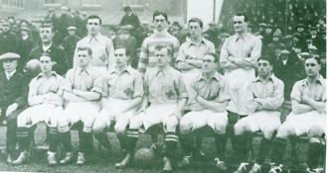

From 1900 to the mid 1930s three soccer players from Ringsend became household names, Valentine Harris, Bob Fulham and James Dunne, pictured left. Between them they played for Shelbourne, Shamrock Rovers, Everton, Leeds, Sheffield United, Southampton, Arsenal and indeed the Ringsenders, all three of them, played for their country. It was a time when the Ringsend area was abundantly rich with soccer venues, clubs and players of all ages.

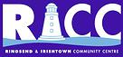
King Kinsella
and St. Vincent’s Foundation Neurology Department
JOINS

in
Annual Community Walk
Monday, May 5
RICC
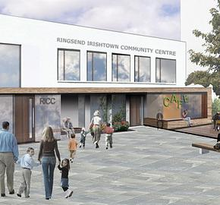
Thorncastle Street Ringsend, D4

The RICC was set up in 1989 to serve the needs of the Community
“From Cradle to Grave”
Sponsor King Kinsella’s Charity Walk go to: http://www.mycharity.ie/event/king_kinsellas_walk/
King’s Supporting Donators for SVF/Neurology

